The Importance of Point Guard Height in Offensive and Defensive Efficiency Compared Between the Regular Season and Playoffs in the National Basketball Association

Ezekiel Snyder

Introduction
The National Basketball Association (NBA) is one of the 4 major sports leagues in the United States of America. The league has 30 teams split into 2 conferences, East and West which contain 15 teams each. Each team plays 82 games and the top 8 teams from each conference advance to the playoffs to compete for the NBA championship.
Basketball has historically had height been the main determinant in a player's position. The guards, Point Guard and Shooting Guard, are the shortest players on the court. The forwards, Small Forward and Power Forward, would then be taller than the guards. The Center would then be the tallest player on any given team. In the past decade we have seen an upheaval of this system. First the style of play known as “small ball” was introduced. Teams would have each of the position groups slide up one, kicking the center off the court entirely. This shorter team allowed for a quicker and more fluid style of play focused on opening up spaces and forcing the defense into switching. As a countermeasure to this style of basketball NBA teams started playing taller guards and now we have players like Shai Gilgeous-Alexander, Cade Cunningham, and Luka Doncic who are all 6 '5+ but play the point guard position. While this trend doesn’t come with its own style of play like small ball, it does come with its own set of expected advantages. A taller point guard has a mismatch offensively inherently as they are taller than most of the other point guards across the league. This forces the opposing team to make the decision whether or not to size up their lineup to match the guards size. A taller point guard can also be expected to make passes easier as they have a natural size advantage making it easier to find the gap for a pass. The height of a taller guard also gives a team a rebounding advantage. There are disadvantages to a taller point guard as well. The taller point guard might not be as dexterous as a shorter point guard and could have a worse handle of the ball, the taller point guard usually will not be as quick as the shorter guard, and the taller guard might not be able to navigate the court as easily as the shorter guard. As basketball evolves and desired height of the offensive initiator changes this leads to the question of does the height of the player truly matter for offensive and defensive outcomes? We have seen that small ball has led to success through the Golden State Warriors era of success, but we have also seen that the lean into height brings success with the Oklahoma City Thunder’s championship win in 2025. The aim of this project is to determine whether or not a point guard's height truly does affect the efficiency of a team's offense and defense and whether or not that effect changes between the playoffs or regular season.

Literature Review
Historically height has been seen as a defining physical characteristic in basketball. It shapes which positions players occupy and how teams will construct their rosters. Despite this, the exact effect of height on performance has remained contested. Three distinct areas of research pertain to this question. The first establishes that position moderates which skills contribute to winning, with findings that contest early assumptions about size and role. The second shows that the team's height relationship to winning is affected by the stakes of the game. The third demonstrates that the performance factors that predict wins change when compared between the regular season and playoffs. Despite the overlap in previous research, no existing study isolates a single position's height and its effect on team efficiency across different game contexts. This study aims to answer that question by examining whether the height of a team’s starting point guard predicts the offensive and defensive efficiency differently compared between the regular season and playoffs.

Previous research shows that position moderates which skills matter for winning. This appears in ways that challenge historical assumptions about size. Page, Fellingham, and Reese (2007) used a hierarchical Bayesian model on box scores from the 1996-97 NBA season to find that defensive rebounding had a significant contribution to point differential in guards, but not in forwards or centers. This is a counterintuitive result as rebounding is usually associated with size and interior presence. The same model also found steals to be an important contribution from centers, this suggests that the traditionally tall position group can derive value from factors not associated with size. A more recent study used modern tracking metrics to support the idea that some positions are more valuable than others. Gong and Chen (2024) used a hierarchical Bayesian plus-minus model on NBA play-by-play data from the 2015-16 to the 2021-22 season in their research. They found that players classified as “Bigs” were consistently the highest performers in defensive plus-minus of the three position groups. This advantage stayed consistent even as the gap between position groups' offensive plus-minus thinned. Another notable finding was that guards exhibited the highest variance in defensive plus-minus, showing that guards possess a uniqueness as a position group when it comes to defensive contributions. A different line of research challenges the adequacy of the traditional position labels. South (2025) compared the traditional three position group classifications (Guard, Forward, Big) to an eleven-archetype positionless model derived from fuzzy k-means clustering of play-type data. South found that his position model only improved prediction of individual game performance by around one percent over the traditional three group model. This suggests that the traditional labels still remain as a sound classification despite the NBA moving into a more fluid and positionless era of basketball. When considering this literature as a whole, these studies establish that positions which take skill contribute to winning, and show areas in which different position groups contribute more than others. These studies do not examine height as a factor in the variance, between position groups nor whether these within-position effects can be extrapolated to team-level outcomes.

A second line of research looks at team height directly, and found that its relationship with winning is not constant given competitive context. Teramoto and Cross (2018) analyzed the 2006-07 to 2015-16 seasons, defining team height as a minutes-weighted average across the roster. They found that team height was uncorrelated with winning percentage in the regular season once offensive and defensive ratings were controlled. This suggests that team height alone brings no tangible regular season advantage independent of team efficiency. This completely flipped in the playoffs. They found that the interaction between height and offensive efficiency became significant. Notably, this interaction flipped directions for each conference. In the Eastern Conference teams with above average offensive efficiency performed better with smaller lineups, while Western Conference teams with above average offensive efficiency performed better with larger lineups. The authors attributed these differences to pace and playing style between the conferences rather than height itself. Teramoto and Cross’ study was the closest existing precedent to the research of this study, but it is limited by height being aggregated across all five positions simultaneously. As a result it cannot determine which position group or interaction between the position groups drives the interaction between offensive efficiency and height in the playoffs. It also cannot identify if the effect represents a single position contribution or a roster wide contribution. This study will directly address this limitation by isolating one position’s height rather than the roster average.

A third body of work shows that the performance factors attributed to winning change between the regular season and playoffs, independent of height. Teramoto and Cross (2010) analyzed ten NBA seasons using multiple linear and logistic regression models to find that shooting efficiency, specifically effective field goal percentage on both ends of the floor, was the strongest predictor of winning in both season types, but that defensive efficiency became more important for winning playoffs series as teams advanced through the tournament, and rebounding becoming a key factor only in the Conference Finals. This pattern was corroborated by Garcia, Ibanez, Martinez De Santos, Leite, and Sampaio (2013), who used discriminant analysis on 323 Spanish ACB league games. They found that in the regular season, winning teams separated from losing teams across a wide set of factors. Assists, defensive rebounds, and shooting efficiency were found to be significant. In the playoffs, these factors were narrowed. Defensive rebounding became the only significant factor separating the winning teams from the losing teams. The same effect is shown across two different basketball leagues studied using different methodologies, strengthening the claim that playoff basketball rewards a more defensive and rebounding oriented style of play when compared to the regular season. However, neither study examines whether this effect operates differently depending on the player’s position, or whether any position’s physical attributes helps explain why defensive rebounding becomes more important in the playoffs.

Considering all of this research together, this literature establishes three important pieces of the question this study addresses. Position has been found to contribute to what skills matter for winning, and guard defensive contributions were particularly variable across players (Gong and Chen 2024; Page, Fellingham, and Reese 2007). Team height was found to have an interaction with season type when predicting efficiency, but only on the aggregate roster level (Teramoto and Cross 2018). The performance factors tied to winning were found to trend towards defense and rebounding in the playoffs, but without any position effect being researched (Garcia et al. 2013; Teramoto and Cross 2010). No study has combined these pieces to find out whether one position’s height, specifically the point guard, affects team offensive and defensive efficiency, and whether that relationship changes given seasonal context. This study addresses that gap directly. It extends Teramoto and Cross’s (2018) framework of team-height by replacing a whole roster, minutes weighted height measure with the height of each team’s starting point guard, to show the effect on team level efficiency across season types.

Data
Data for this study were collected from the “Historical NBA Data and Player Box Scores” dataset (Amoore, 2024), a publicly available Kaggle dataset. The dataset aggregates official NBA box score and player biographical records. This data set was used over the NBA’s own stats API because of repeated access restrictions encountered when trying to query that API directly. The Kaggle dataset provides data of a similar scope and granularity. This includes player-game level box score, capturing starting lineup designation and in-game statistics, player biographical records such as height, and team-game level advanced statistics such as offensive and defensive rating.

The sample was constructed using the following inclusion criteria, applied sequentially. Initially a sample was taken of all game observations from the 2016-2017 through 2024-25 season for which starting lineup data was recorded. This sample was then restricted to games with exactly 5 recorded starters, excluding a small number of games affected by data duplication or incomplete lineup records. The sample was then further restricted to include only Regular Season and Playoff games, excluding the All-Star, Play-In tournament, and NBA Cup games. Finally two seasons 2016-17 and 2021-22 were excluded entirely because of systematic issues with the source data. In the case of 2016-17 starting lineup data was substantially duplicated, whereas in 2021-22 the data was almost entirely missing. This made it hard to apply the point guard identification procedure described in the methodology section. The final sample consists of 17,722 team-game observations across 7 seasons (2017-18 through 2024-25, ex. 2021-22) of NBA basketball. This is broken down into 16,558 regular season games and 1,164 playoff games, and is drawn from 8,861 unique games across all 30 NBA teams.

Descriptive Statistics Table for Regular Season Observations (Table 1)

Variable | Mean | SD | Min | Max
N (team-games) | 16558
Starting PG Height (z-score) | 0 | 1 | -3.6 | 3.5
Starting PG Height (in.) | 75.45 | 2.25 | 68 | 84
Other Starters' Avg. Height (in.) | 79.48 | 0.99 | 75.8 | 83.8
Team Offensive Rating | 111.74 | 11.56 | 67.3 | 158.8
Team Defensive Rating | 111.74 | 11.56 | 67.3 | 158.8
Opponent Season ORtg | 111.74 | 4.03 | 102.9 | 122.3
Opponent Season DRtg | 111.74 | 3.62 | 101.7 | 119.7
Home Game (%) | 50.00%
Win (%) | 50.00%

Descriptive Statistics Table for Playoff Observations (Table 2)

Variable | Mean | SD | Min | Max
N (team-games) | 1164
Starting PG Height (z-score) | 0.02 | 1.01 | -2.3 | 2.9
Starting PG Height (in.) | 75.52 | 2.34 | 70 | 82
Other Starters' Avg. Height (in.) | 79.44 | 1.01 | 76.5 | 82.5
Team Offensive Rating | 111.27 | 11.99 | 73.4 | 148.1
Team Defensive Rating | 111.27 | 11.99 | 73.4 | 148.1
Opponent Season ORtg | 114.22 | 3.57 | 103 | 122.3
Opponent Season DRtg | 110.55 | 3.07 | 103 | 117.6
Home Game (%) | 50.00%
Win (%) | 50.00%

Tables 1 and 2 present descriptive statistics for the regular season and playoff samples, respectively. There are several notable patterns worth pointing out. First, the height of the starting point guard is essentially identical across both season types (M = 75.45 inches for the regular season, M = 75.52 inches in the playoffs). This suggests that the size of the player starting at the point guard position does not change meaningfully given game context. This means that any difference in how point guard height relates to team efficiency between season types would reflect a shift in the relationship between those variables rather than a shift in who is playing the position across game contexts. Second, playoff opponents are measurably stronger than regular season opponents. Playoff teams face higher offensive ratings (M = 114.22 versus M= 111.74) and lower defensive rating (M = 110.55 versus M = 111.74) in the playoffs than they do in the regular season. This supports previous work that competition increases in the post season because weaker teams are eliminated from contention (Teramoto & Cross, 2010). It also shows the importance of including opponent quality as a control variable in our model. Third, team offensive and defensive ratings show a significant variation across both season types (SD ≈ 11.6-12.0). This indicates meaningful variation game to game in team efficiency that our model can explain. Note that offensive and defensive ratings are pooled distributions and are numerically identical across the full sample. This is expected for team-game level data as one teams offensive rating will be their opponents defensive rating for any given game. Finally, the range of starting point guard height (68-84 inches in the regular season) shows a considerable variation in point guard size giving this study the size diversity it needs.

Methodology

Point Guard Identification
A key methodological challenge in this study is that NBA box score data typically labels starting players only by a broad position category (guard, forward, center) rather than by specific position; this is the case with the box score data collected for this study. This is a direct obstacle to isolating the effect of specifically the point guard’s height.

To address this, the classification of starting point guard was specified using an assist-based proxy. For each five starter classified game there are two starting players recorded with the “G” (guard) label. The player with the higher assist total in that game is classified as the starting point guard, while the remaining starter is treated as the shooting guard. Ties are broken using minutes played, with the higher minutes player being classified as the starting point guard. This approach follows the well established distinction in playmaking responsibility between the two guard positions. Playmaking has traditionally been a defining responsibility of the point guard position. This classification procedure was assessed for reliability before its use in the final sample. Across games with exactly two starting guards, the player classified as the point guard averaged 3.91 more assists per game than the other starting guard. This indicates that the procedure typically identified a clear playmaking leader. An exact assist tie, triggering the minutes based tiebreaker, occurred in 8.5% of games. This method is still a proxy rather than an official position designation, so it carries limitations worth noting. A small number of players may be misclassified. This could occur in situations where a team possesses a high assist combination guard, or in blowout games where unusual lineup and playing-time patterns may change the typical assist distributions. Given that the tie rate is low and the average assist margin is high it is likely that this method is correctly identifying the starting point guard in the majority of the sample.

Variable Definitions

Starting Point Guard Height
(StartingPGHeightZ). The primary independent variable is the height of the starting point guard for any given game, identified using the process above. Height was standardized to a z-score within each season rather than across the pooled sample. This is so that a player’s height is expressed in relation to the distribution of starting point guard’s height in that specific season. This choice was made so that a point guard’s height is evaluated relative to their contemporaries, accounting for the trend towards taller guards.

Other Starters’ Average Height
(OtherStartersHeight). This variable is needed to isolate the specific contribution of point guard height from overall team size. It is the average height of the 4 other starters for any given game. Without this included as a control variable any observed relationship between point guard’s height and team efficiency could reflect overall team size rather than the specific point guard’s height effect.

Season Type
(Playoff). This is a binary indicator used to distinguish between playoff games (coded 1) from regular season games (coded 0). This variable’s interaction with starting point guard height is the central test of the study.

Opponent Quality
(opp_season_ORtg, opp_season_DRtg). To account for variation in opponent strength, each game was paired with the opponent's average offensive and defensive ratings. These averages were calculated using only the opponent’s regular season games, regardless of game context. This was a deliberate choice to not use noisy playoff-only metrics based on significantly smaller samples.

Home Court
(Home). This is a binary indicator used to denote if a team is playing home (coded 1) or away (coded 0) for each game.

Outcome Variables
(TeamORtg, TeamDRtg). The two dependent variables for this study are the team’s offensive and defensive rating for that specific game. These variables are modeled separately, and will produce two parallel regression specifications rather than a single combined model.

Model Specification

The relationship between starting point guard height and team efficiency was estimated using the following regression equation, specified separately for team offensive rating and team defensive rating as outcome variables:

TeamORtg/TeamDRtg = β₀ + β₁(StartingPGHeightZ) + β₂(Playoff) + β₃(StartingPGHeightZ ✕ Playoff) + β₄(OtherStartersHeight) + β₅(opp_season_ORtg or opp_season_DRtg) + β₆(Home) + Season Fixed Effects + ɛ

In this specification, β₁ captures the main effect of a starting point guard’s height on team efficiency in the regular season, while β₂ captures the average difference in team efficiency between playoff and regular season games, holding all other variables constant. The coefficient of most interest is β₃, this is the interaction between point guard height and season type. This tests whether the relationship between our outcome variables and point guard height differs given game context. A statistically significant and positive β₃ means that taller point guards are associated with a larger efficiency advantage in the playoffs than in the regular season, whereas a statistically significant negative β₃ would indicate the opposite. Season fixed effects are included to account for league-wide changes in other factors across the sample period that are unrelated to the variables of interest.

This model is estimated twice using identical specifications. Once with team offensive rating as the dependent variable and once with team defensive rating as the dependent variable. This produces two sets of results rather than a single combined result. This allows point guard height to be evaluated separately for its offensive and defensive effects.

Estimation Approach

The model was estimated using pooled ordinary least squares (OLS) regression, with standard errors clustered at the team-season level. Clustering is used to account for the fact that repeated observations from the same team within the same season are not statistically independent. Games played by the same roster with the same coaching staff share unobserved factors such as team chemistry, coaching strategy, and injuries that are not captured by the control variables. Without this adjustment standard errors would be understated and statistical significance overstated.

An alternative approach would have been to include player or team level fixed effects. This is commonly used for panel data to account for unobserved, unaffected by time characteristics of each unit. This approach was not used in this study. This is because starting point guard height is a largely constant factor within a given team’s season besides trades, injuries, or coaching decisions. Including a team’s season fixed effect would absorb most of the variation in starting point guard height and thus leave the model with nothing to estimate the effect, making the coefficient of interest almost impossible to identify. Clustered standard errors were determined to be the better choice as they correct for non-independence in the data while preserving the effect we are looking for.

Scope and Limitations

There are several scope decisions and limitations that need to be noted. First, due to time constraints, the number of rest days a team had before each game was not included as a control variable. Previous research has shown rest to be a key factor in team performance, and its omission represents an important piece of missing information. Future iterations of this study will incorporate rest as a control variable.

Second was the ambiguity of position labeling in the NBA box score data. This was discussed above in the Point Guard Identification subsection. As positional roles in the NBA continue to become more fluid, standard box score position tags offer a less reliable basis for position-based analysis (South, 2025). While the assist-based proxy used in this study was shown to be reliable in the majority of cases, there is still a chance for some misclassification that cannot be ruled out.

Third, the exclusion of the 2016-17 and 2021-22 seasons due to data quality issues was a limitation. This reduced the continuity of the sample. There is no reason to expect that the specific data quality issues identified in those seasons are related to starting point guard height or team efficiency. The missing data appears to stem from incomplete lineup-tagging in the source dataset. This exclusion is unlikely to have introduced systematic bias but does leave a gap in the panel of seasons examined.

Finally, opponent quality was measured using full season average offensive and defensive rating, rather than a measure specific to that opponent’s form or roster construction at the time of a specific game. This provides a stable, low noise measure of opponent strength. It does not capture game-to-game fluctuations in opponent performance making it a limitation.

Results

Regression Results Table For Both Models (Table 3)

Variable | Team Offensive Rating | Team Defensive Rating
Intercept | 14.453 (13.885) | 19.643 (12.260)
StartingPGHeightZ | 0.074 (0.144) | 0.017 (0.146)
Playoff | 0.687+ (0.371) | -2.965*** (0.441)
StartingPGHeightZ:Playoff | 0.308 (0.390) | -0.318 (0.429)
OtherStartersHeight | -0.183 (0.166) | -0.222 (0.150)
Opponent Quality Control | 0.992*** (0.031) | 0.992*** (0.026)
Home | 2.150*** (0.169) | -2.135*** (0.175)
Season Fixed Effects | Yes | Yes
N | 17,722 | 17,722
R-squared | 0.103 | 0.126

*Opponent Quality Control differs, it is Opponent Offensive Rating for the Team Defensive Rating model and vice versa for the Team Offensive Rating model*

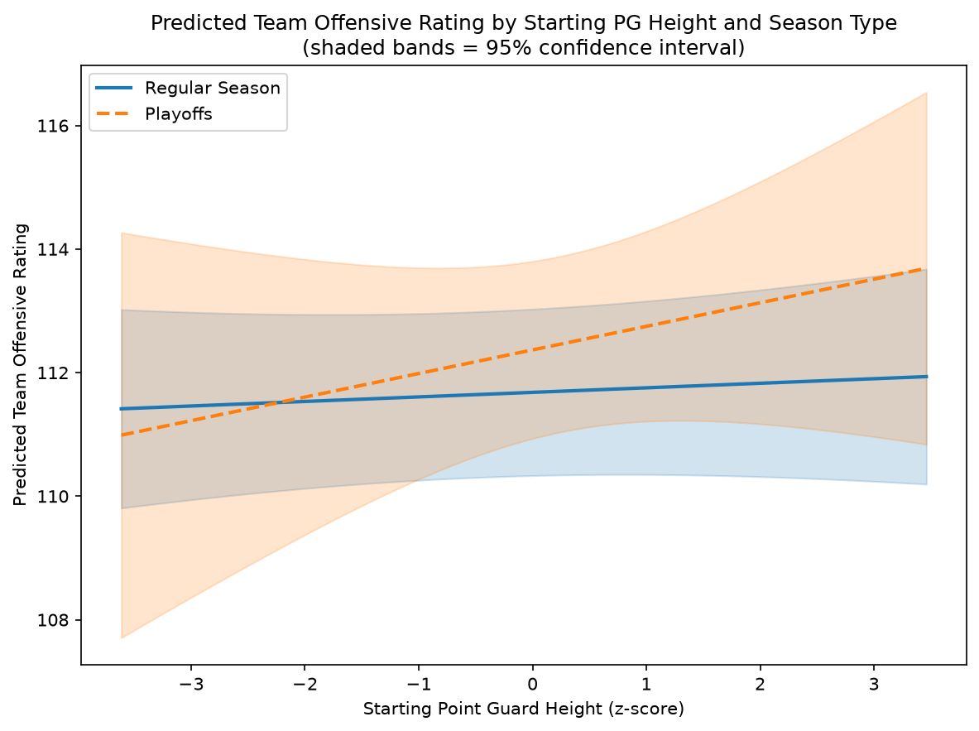
(Figure 1)
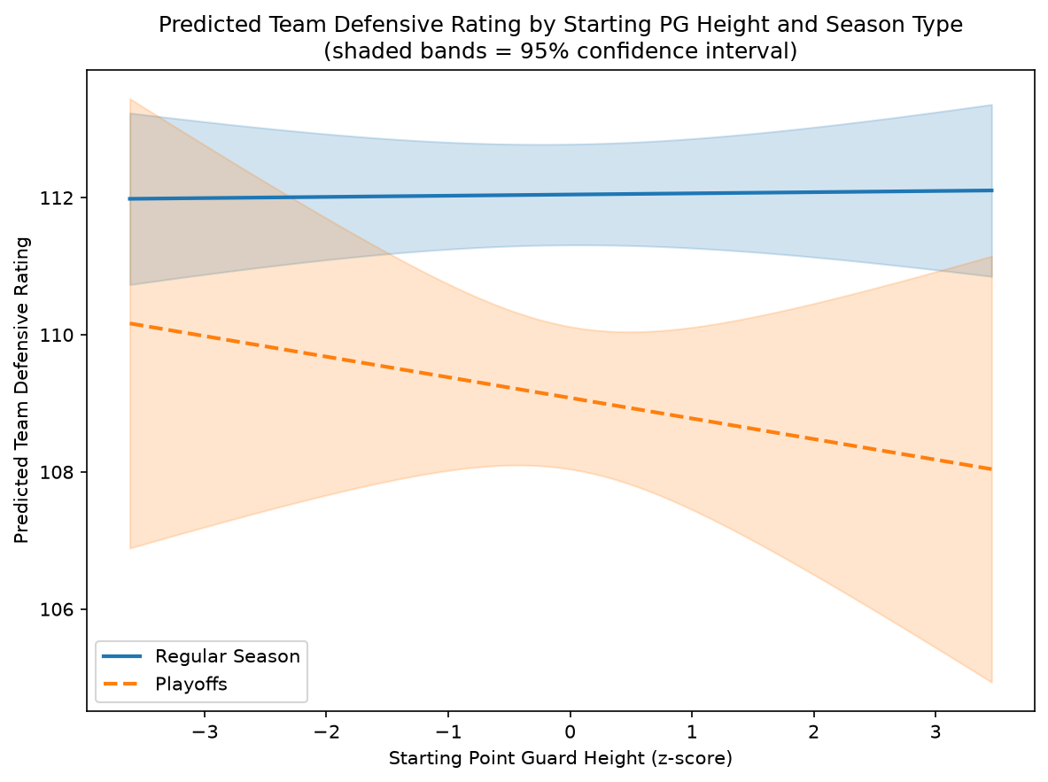
(Figure 2)
Offensive Rating

Table 3 presents the coefficients from the offensive rating model in column two, and Figure 1 displays the corresponding predicted values banded with a 95% confidence interval. The model explains a modest but statistically significant portion of the variance in team offensive rating (R² = 0.103, F(12, 17709) = 126.5, p < .001, N = 17,722). The main coefficient, the interaction between starting point guard height and season type, was not statistically significant (β = 0.308, SE = 0.390, p = .429). This shows no detectable difference in the relationship between point guard height and offensive rating across season types. The singular effects of starting point guard height (β = 0.074, p = .609) and season type (β = 0.687, p = .064) were also not significant. Although, it should be noted that season type approached the traditional p < 0.05 threshold. The control variables showed their expected effects. Opponent season level defensive rating was a strong, significant predictor of team offensive rating (β = 0.992, p < .001), as well as home court (β = 2.150, p < .001).

Defensive Rating

Table 3 also presents the coefficients from the defensive rating model in column three, and Figure 2 displays the corresponding predicted values banded with a 95% confidence interval. Similarly, the model explains a statistically significant but modest portion of the variation in team defensive rating (R² = 0.126, F(12, 17709) = 160.9, p < .001, N = 17,722). Results are consistent with the offensive rating model. The interaction between starting point guard height and season type was not statistically significant (β = -0.318, SE = 0.429, p = .459). This indicates a similar non-detectable relationship between defensive efficiency and starting point guard height across season types as offensive efficiency. The singular effect of starting point guard height was also not significant (β = 0.017, p = .906). The singular effect of season type was found to be highly statistically significant and substantial in the defensive model, contrasting the offensive model (β = -2.965, SE = 0.441, p < .001). This means a team’s defensive rating improves by nearly 3 points per 100 possessions in the playoffs compared to the regular season, holding all other variables constant. The control variables again showed their expected effects. Opponent offensive rating was a strong and significant predictor of team defensive rating (β = 0.992, p < .001). Home court was also significant (β = -2.135, p < .001).

Summary of Findings

Across both models, the interaction between starting point guard height and season type was not statistically significant. This provides no evidence that the relationship between point guard height and team efficiency differs between the regular season and the playoffs. One pattern did emerge through these models, team defensive rating improved substantially in the playoffs relative to the regular season. There is also a feature of Figure 1 worth discussing, the regular season and playoff lines for offensive rating numerically cross. Given that the interaction term between these two variables was not statistically significant and the confidence intervals of the two lines overlap for the entirety of the range of observed point guard height, the crossing should not be interpreted as a statistically distinguishable feature of the data. The implication of these findings will be expanded upon in the discussion section.

Discussion

The absence of a significant interaction between starting point guard height and season type in either model suggests that, within this sample, a point guard’s height does not meaningfully alter how a team’s offensive or defensive efficiency shifts between the regular season and playoffs. Teramoto and Cross (2018) found that team height, aggregated across all five roster positions, does interact significantly with offensive rating in the playoffs. Their study could not identify which position was responsible for the effect they found, creating a motivation for this study. This study’s findings offer a step towards answering that question. It suggests that the point guard position is not where the team-level height effect is shown. An alternative methodological explanation is worth discussing as well. The height range of NBA point guards is already narrow (SD ≅ 2.25-2.34 across season types). This tight range might limit the degree of true variation for the model to detect an effect. Future work using a larger more height diverse sample could help distinguish between a true absence of effect and obscuration through limitation in the variance of the predictor.

Despite starting point guard height and season type showing no significant interaction, a clear main effect emerged independently. Team defensive rating improved by nearly three points per 100 possessions relative to the regular season, holding all else constant. This finding is consistent with the prior work of Teramoto and Cross (2010) on how performance factors shift between season types. Their work found that defense becomes more important in winning playoff games as teams advance through the tournament, even as shooting efficiency remains the strongest predictor of winning in both game contexts. The present finding demonstrates that the playoff increase in defensive efficiency is a league-wide phenomenon that occurs independent of a team's starting point guard height. This result suggests that whatever drives the team-level interaction between season type and defensive efficiency is not attributable to a starting point guard’s height, but rather is most likely driven by roster construction or a different position's specific height effect. Taken with the non-significant interaction discussed above, this significant result suggests that defense intensifies in the playoffs for reasons that are uniform across all teams.

There are several features of the sample that should be considered when interpreting the non significant interaction terms reported above. Most notably, the playoff sample (n = 1,164) is much smaller than the regular season sample (n = 16,558). This is an unavoidable consequence of the NBA’s playoff structure. A smaller sample reduces statistical power, meaning that a true interaction effect of modest size could exist. The non-significant result reported in this study should be interpreted as an absence of detected evidence, not as definitive evidence that no interaction exists. This bears directly onto a feature of Figure 1 worth revisiting. The predicted lines for team offensive rating, drawn from the regular season and playoff models, numerically cross. Considered in isolation this could appear to suggest that shorter point guards face a playoff disadvantage in offensive efficiency. However, because the interaction term producing this pattern was not statistically significant, and because the two line’s 95% confidence intervals overlap across the entire height range, this crossing cannot be distinguished from pure sampling noise. It is reported to show a descriptive feature of the fitted model rather than evidence of a relationship, and should not be interpreted as such.

Within this sample, there is no evidence to suggest that teams should prioritize having a tall starting point guard to improve offensive or defensive efficiency in either the regular season or the playoffs. This is counterintuitive to the rising success of taller lead guards such as Cade Cunningham, Luka Doncic, and Shai Gilgeous-Alexander, discussed in the introduction of this study. These players may offer individual advantages unrelated to team-level efficiency, such as switchability on defense or mismatch scoring opportunities, but the present results do not show that their height is what specifically leads to their success in playoffs versus the regular season.

There are multiple directions for future research. First, following up on the research of Teramoto and Cross (2018) to find which position may be driving the team-level height and playoff interaction is worth exploring. Applying this study’s methodology to center or forward height would help determine if the effects found in Teramoto and Cross’s 2018 study concentrate on these position groups instead. Future work would benefit from a larger sample to account for the statistical limitations discussed above, as well as the addition of rest days between games as a control which was excluded due to time constraints. Finally incorporating a better, more precise way of distinguishing between point guards and shooting guards, rather than the assist based proxy used would strengthen the assuredness of these findings.

Citations

García, J., Ibáñez, S. J., Martinez De Santos, R., Leite, N., & Sampaio, J. (2013). Identifying basketball performance indicators in regular season and playoff games. Journal of Human Kinetics, 36, 161–168. https://doi.org/10.2478/hukin-2013-0016
Gong, H., & Chen, S. (2024). Estimating positional plus-minus in the NBA. Journal of Quantitative Analysis in Sports, 20(3), 193–217. https://doi.org/10.1515/jqas-2022-0120
Page, G. L., Fellingham, G. W., & Reese, C. S. (2007). Using box-scores to determine a position's contribution to winning basketball games. Journal of Quantitative Analysis in Sports, 3(4), Article 1. https://doi.org/10.2202/1559-0410.1033
South, C. (2025). A basketball paradox: Exploring NBA team defensive efficiency in a positionless game. Journal of Quantitative Analysis in Sports, 21(4), 345–359. https://doi.org/10.1515/jqas-2024-0010
Teramoto, M., & Cross, C. L. (2010). Relative importance of performance factors in winning NBA games in regular season versus playoffs. Journal of Quantitative Analysis in Sports, 6(3), Article 2. https://doi.org/10.2202/1559-0410.1260
Teramoto, M., & Cross, C. L. (2018). Importance of team height to winning games in the National Basketball Association. International Journal of Sports Science & Coaching, 13(4), 559–568. https://doi.org/10.1177/1747954117730953

Amoore, E. (2024). Historical NBA data and player box scores [Data set]. Kaggle. https://www.kaggle.com/datasets/eoinamoore/historical-nba-data-and-player-box-scores

